Sales Ledger Invoice Create Flow – vNext (Implementation 2.4)
Updated: 2025-10-17 13:02:36Z (UTC)

Revision Summary
• Implemented centralized audit logging for success and failure events using AuditLogging configuration.
• Added persistence of ResultSageUrn in IdempotencyRecords when Idempotency-Key provided.
• Maintained DB-only persistence pattern: ExternalIdLink + IdempotencyRecord; outbound HTTP excluded from EF transactions.
• Ensured Swagger displays Authorization, X-Site, X-Company, and Idempotency-Key headers.
• Unified error mapping to return HTTP 502 ProblemDetails with upstream preview text on non-2xx responses.

End-to-End Flow Overview
1. POST /api/SalesInvoices receives Authorization, X-Site, X-Company, and Idempotency-Key headers.
2. DTO validation occurs; resolves AppId from X-Api-Key when omitted in ExternalRefs.
3. Service constructs snake_case payload; forwards headers via ISageApiClient pipeline.
4. Delegating handlers add correlation IDs, apply logging, and refresh OAuth tokens when needed.
5. Sage responds with URN (2xx) or error (non-2xx).
6. On success, DB-only transaction persists ExternalIdLink and IdempotencyRecord.ResultSageUrn.
7. On failure, HTTP 502 ProblemDetails is returned with upstream preview and audit log recorded.

Microservice Audit & Persistence Flow
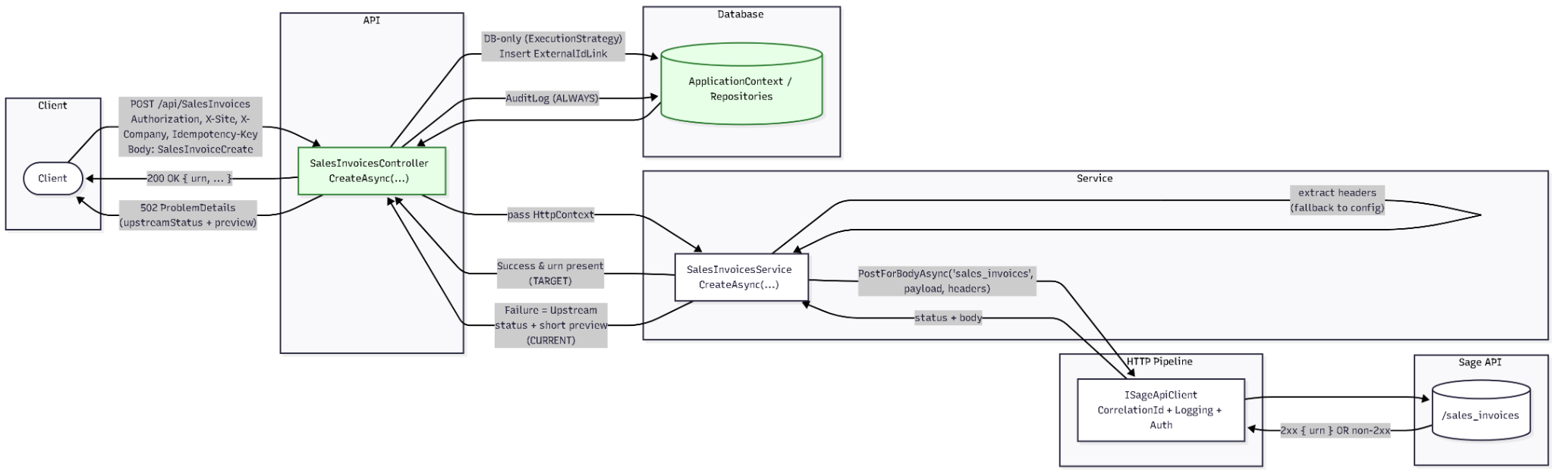
Figure 1 — Sales Ledger Invoice Microservice Flow (Success & Failure)

Kafka Process Flow (Reference)
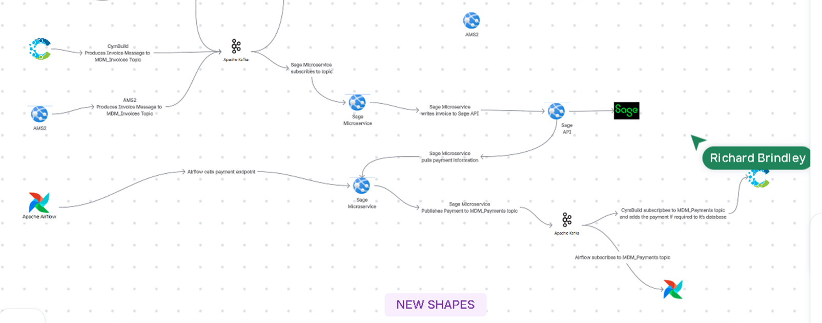
Figure 2 — Kafka Integration Flow (CymBuild → Kafka → Sage Microservice → Sage 200)

Header Handling & Idempotency
Header | Source | Applied | Purpose
Authorization: Bearer … | OAuth / SageAuthDelegatingHandler | Outbound Sage request | Authenticate to Sage
X-Site | HTTP header or configuration | Forwarded to Sage | Tenant/site routing
X-Company | HTTP header or configuration | Forwarded to Sage | Company routing
Idempotency-Key | HTTP header | Forwarded + persisted | Ensure idempotent create semantics

Error Mapping
All non-2xx responses from Sage are mapped to HTTP 502 ProblemDetails. The 'detail' field includes a truncated upstream response preview, and 'upstreamStatus' is logged for audit traceability.

